

|  |  |
| --- | --- |
|  | Lab 1: Hands on AWS and Azure introduction |
|  |  |
|  | Akshar Panchani ID- 202101522  IT457 Cloud Computing  1/21/24 |

**Intro to Azure Fundamentals**

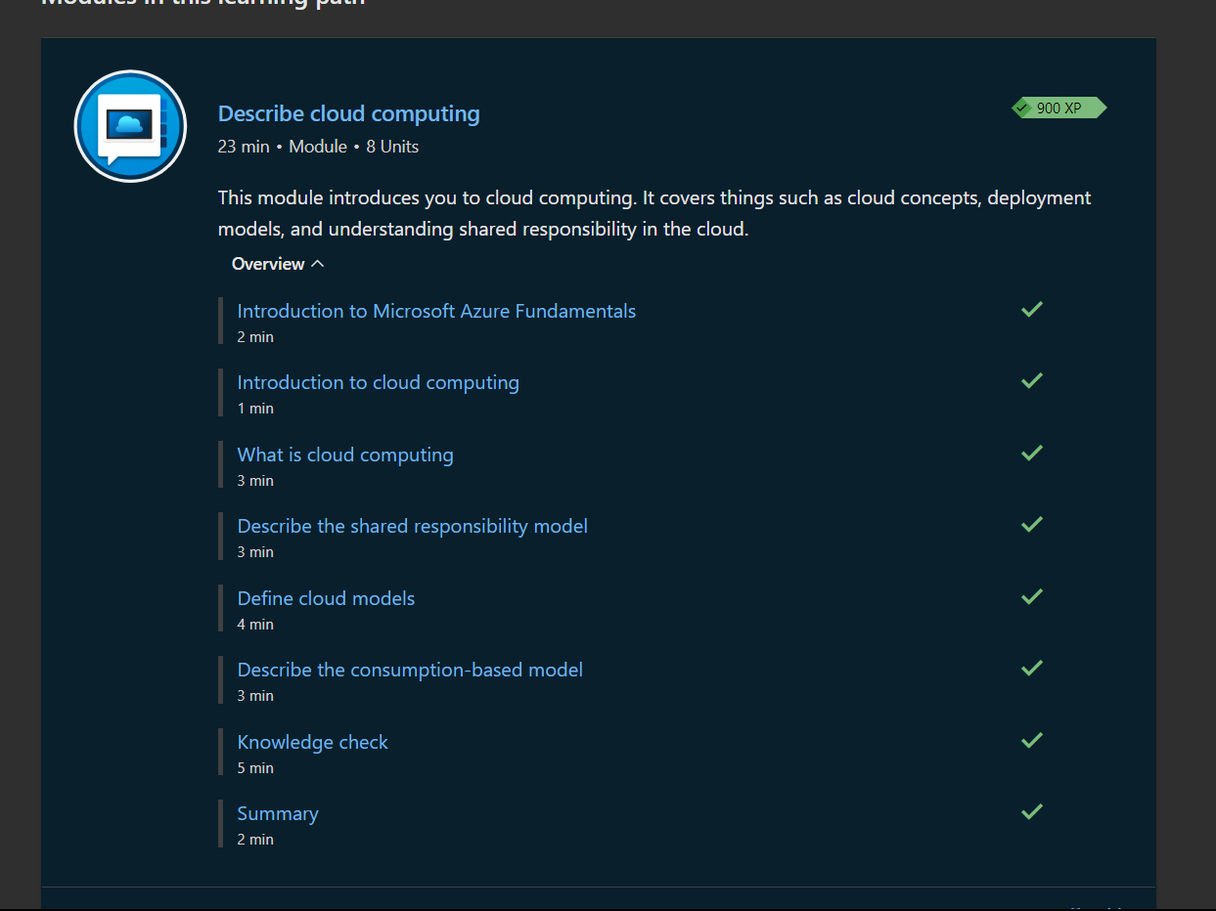

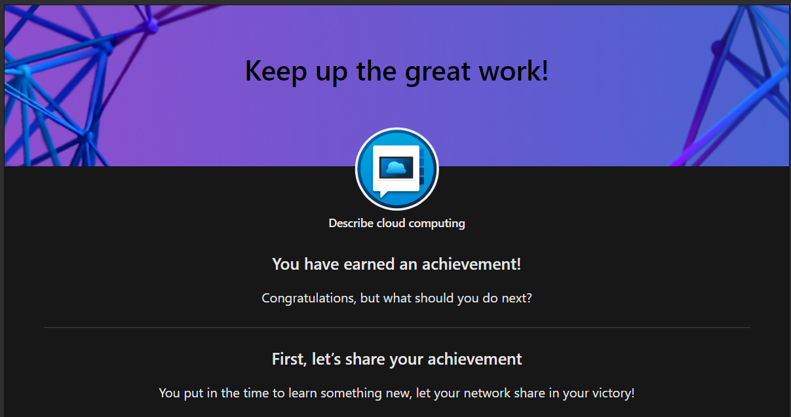

**Making availability set.**

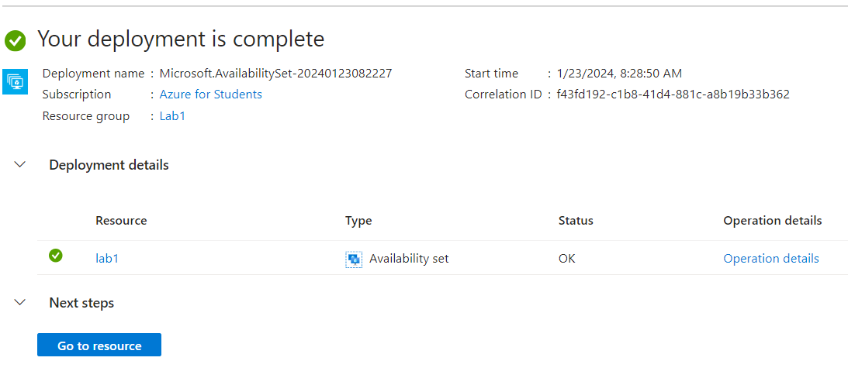

**Public load**

Creating NAT Gateway

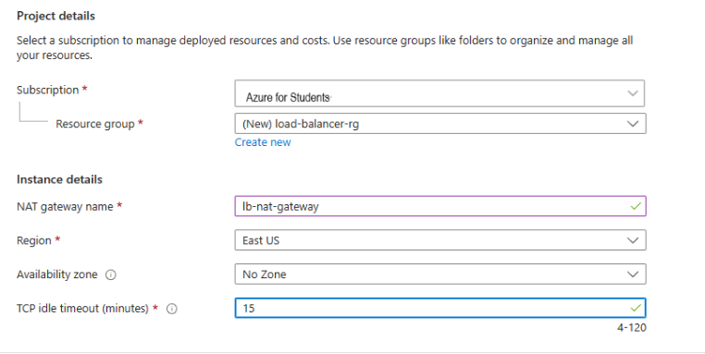

**Load Balancer**

* Power Shell in VM1:

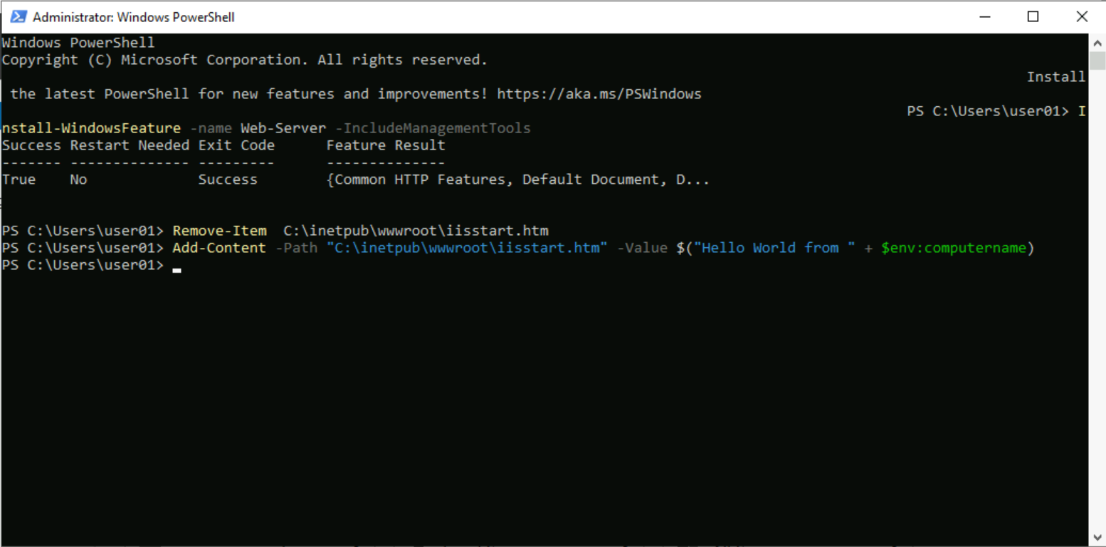

* Power Shell in VM2:

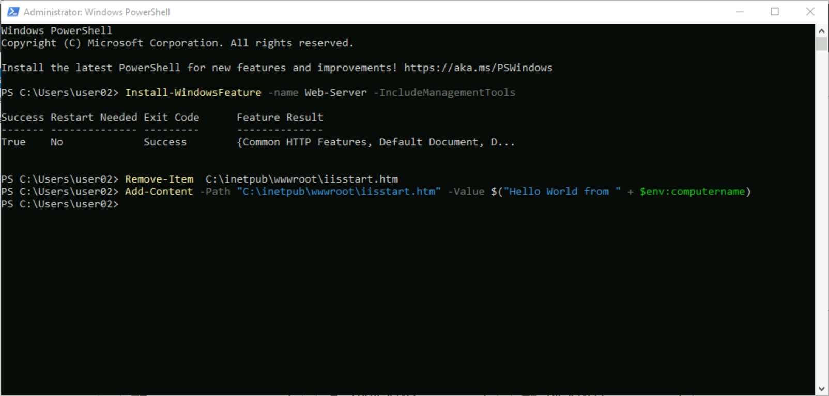

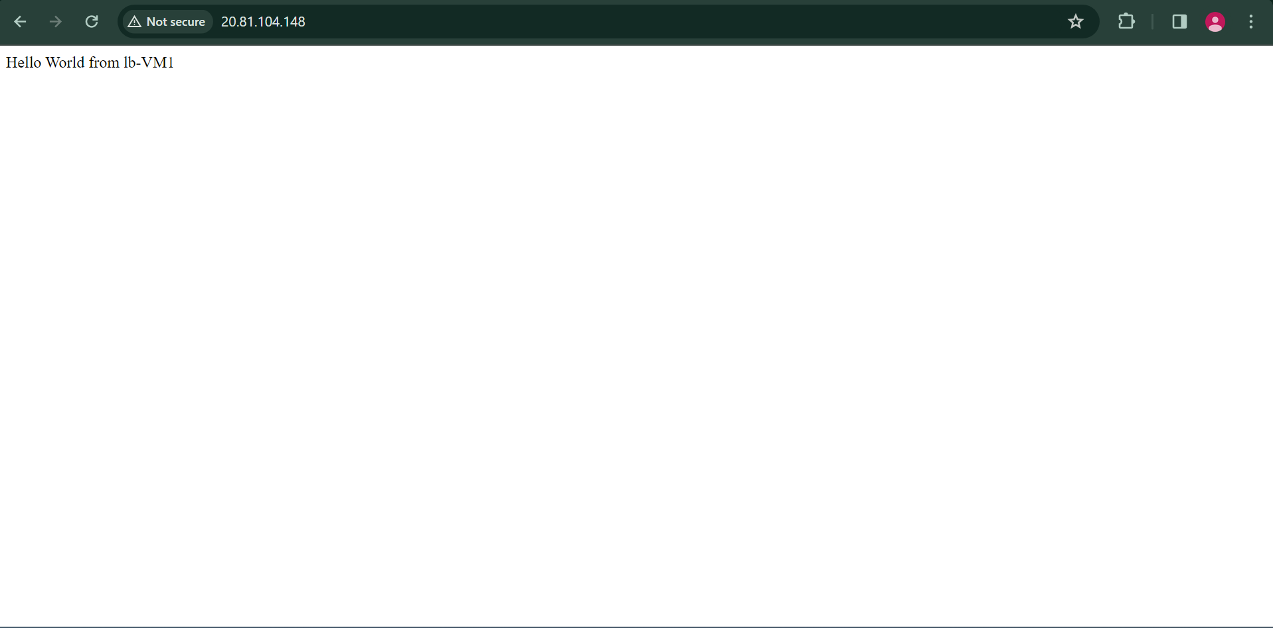

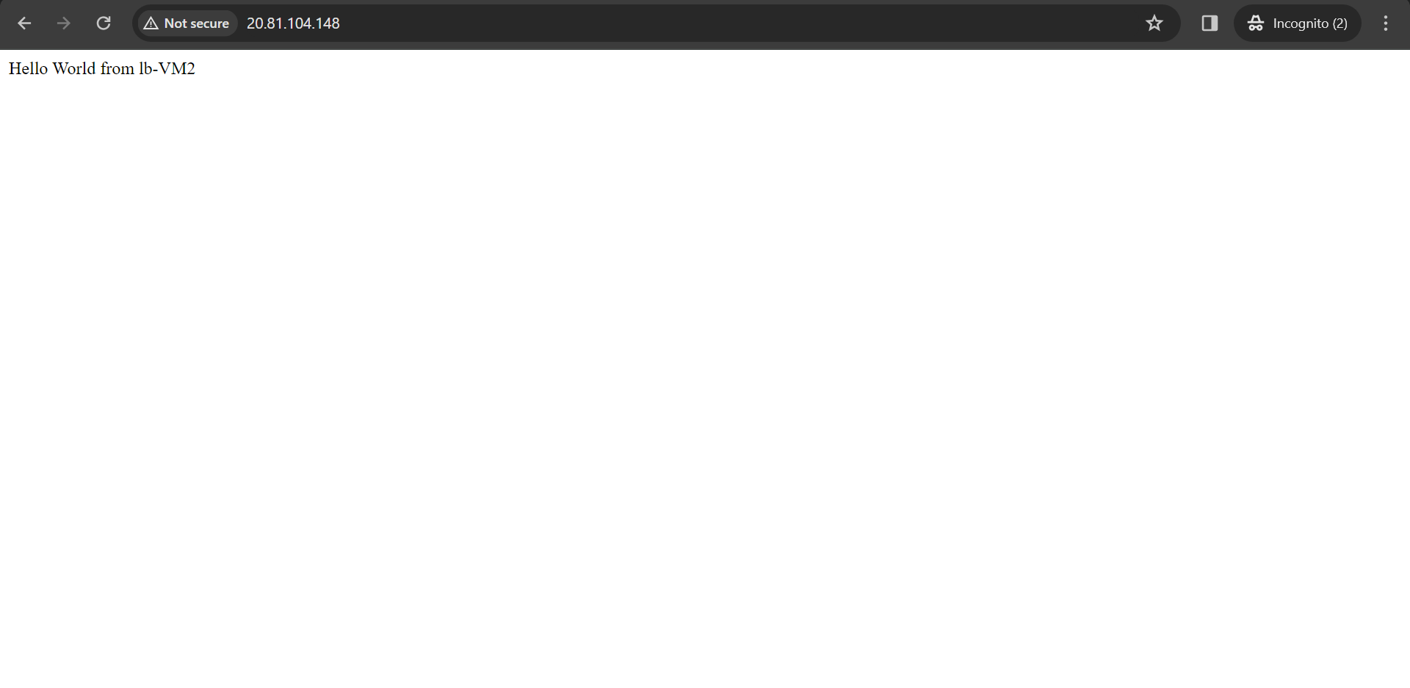

**Internal Load**

Making VM1



* Power Shell in VM2:



* Output in VM1:

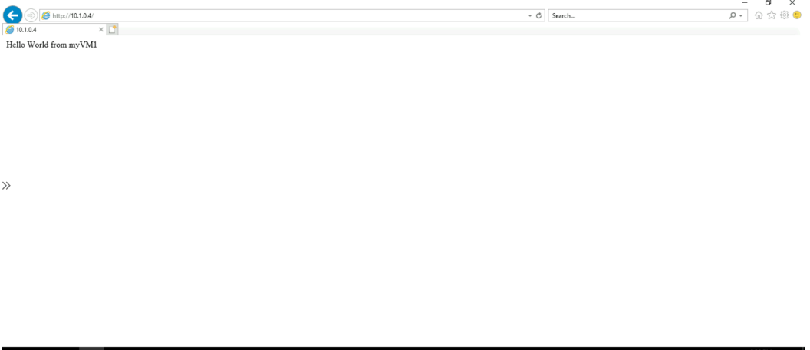

* Output in VM2:

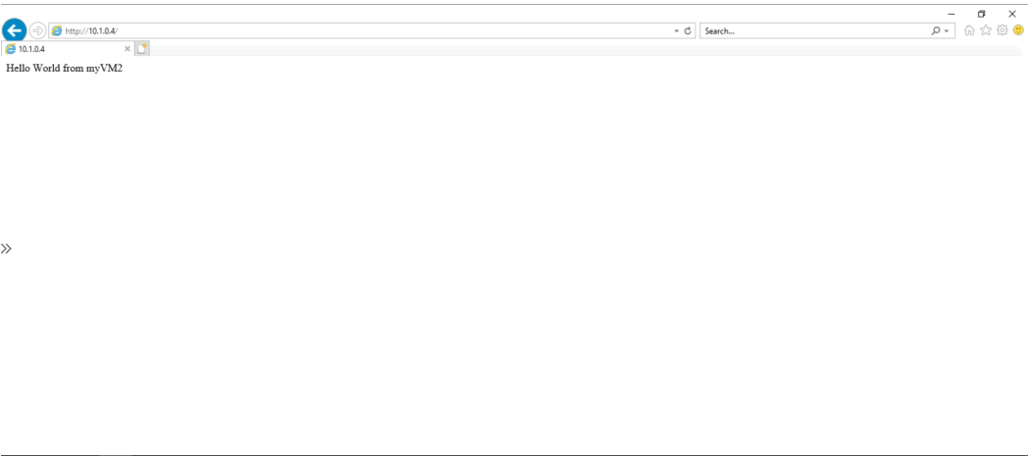

**Azure Load Balancer:**

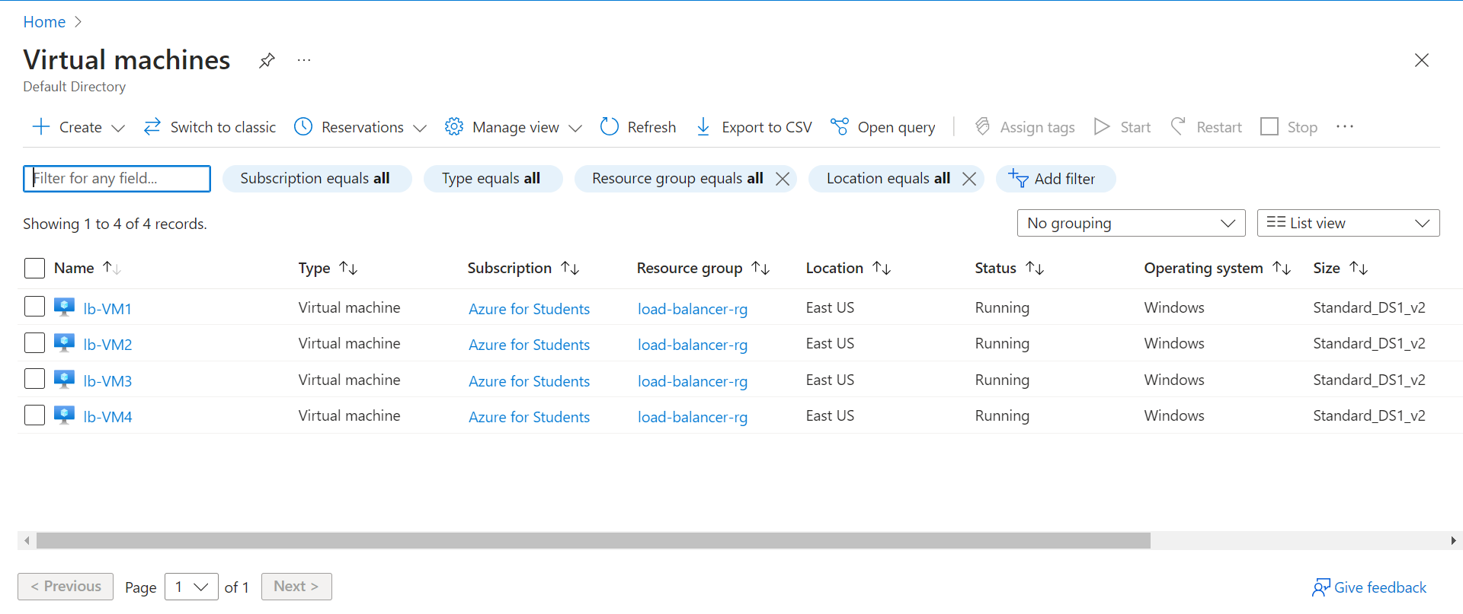

* VM1:

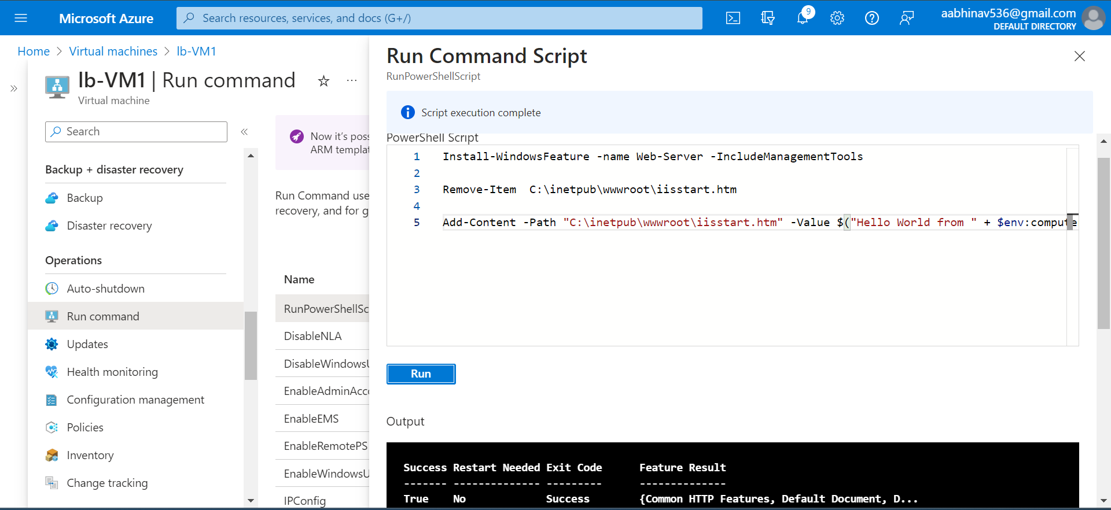

* VM2:

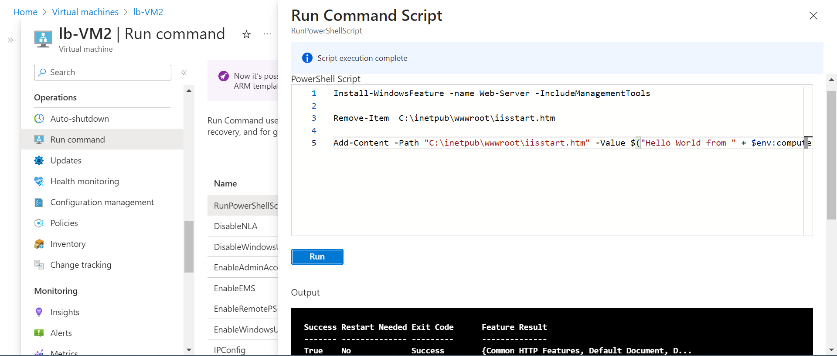

* VM3:

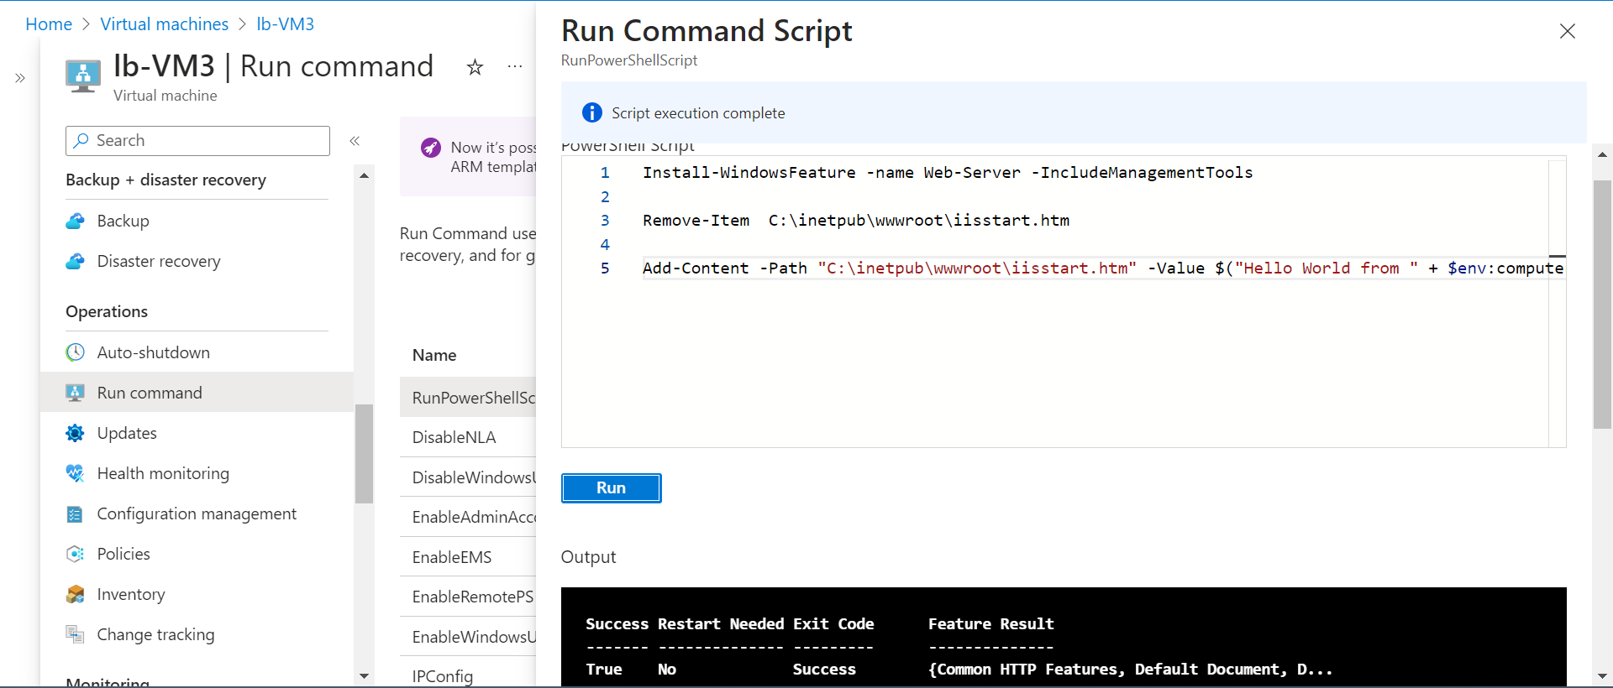

* VM4:

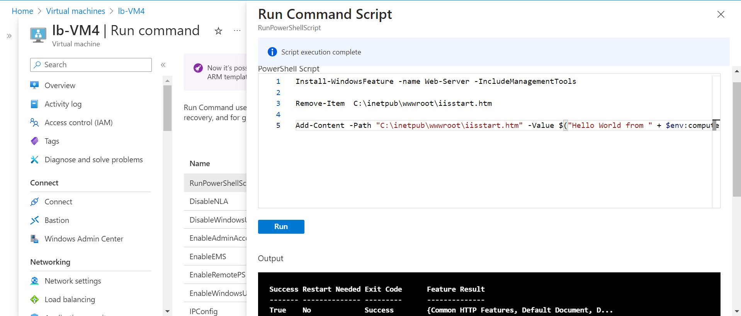

IP Address:

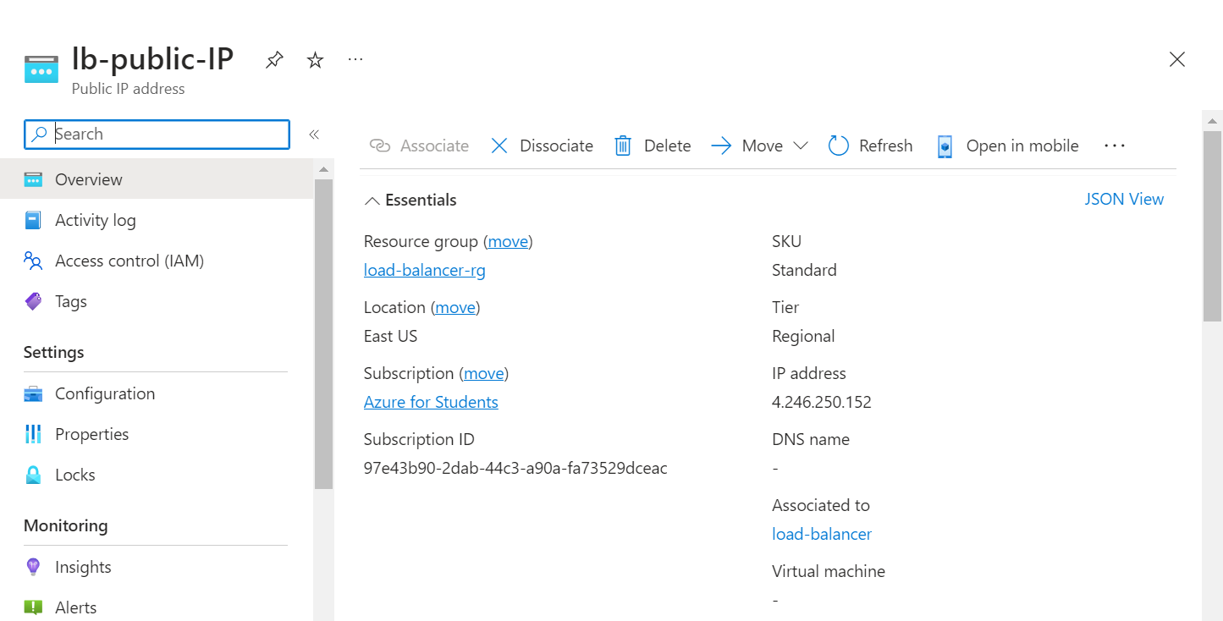

Outputs:

* VM1:

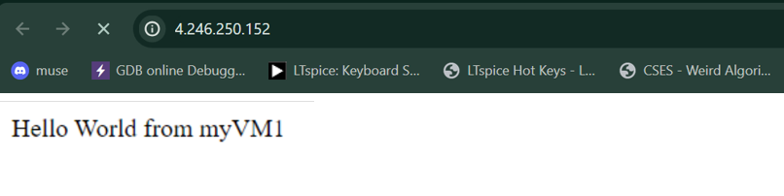

* VM2:

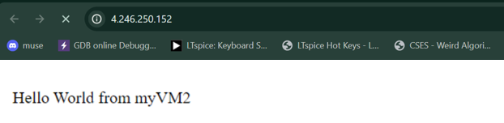

* VM3:

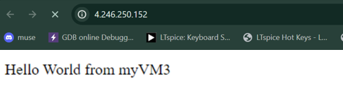

* VM4:

